stroopGroup3.R

Samuel

Sat Nov 10 16:08:29 2018

# Sam Tenney  
# stroopGroupX.R  
# Homework 9  
  
# Read in the data  
stroop <- read.table(text = "Run Block blockRun Task timerDisplay Time  
1 Thomas 1 Color No 63.84  
2 Thomas 2 Shape No 69.069  
3 Thomas 3 Shape Yes 69.869  
4 Thomas 4 Color Yes 59.477  
5 Sam 1 Shape No 54.02  
6 Sam 2 Color Yes 51.949  
7 Sam 3 Color No 48.16  
8 Sam 4 Shape Yes 50.113  
9 Wade 1 Shape No 61  
10 Wade 2 Color No 60.997  
11 Wade 3 Shape Yes 57.159  
12 Wade 4 Color Yes 57.176  
13 Cory 1 Color No 59.205  
14 Cory 2 Shape Yes 55.484  
15 Cory 3 Shape No 55.556  
16 Cory 4 Color Yes 52.77  
", header = TRUE, sep = "")  
  
# Look at the data  
str(stroop)

## 'data.frame': 16 obs. of 6 variables:  
## $ Run : int 1 2 3 4 5 6 7 8 9 10 ...  
## $ Block : Factor w/ 4 levels "Cory","Sam","Thomas",..: 3 3 3 3 2 2 2 2 4 4 ...  
## $ blockRun : int 1 2 3 4 1 2 3 4 1 2 ...  
## $ Task : Factor w/ 2 levels "Color","Shape": 1 2 2 1 2 1 1 2 2 1 ...  
## $ timerDisplay: Factor w/ 2 levels "No","Yes": 1 1 2 2 1 2 1 2 1 1 ...  
## $ Time : num 63.8 69.1 69.9 59.5 54 ...

head(stroop)

## Run Block blockRun Task timerDisplay Time  
## 1 1 Thomas 1 Color No 63.840  
## 2 2 Thomas 2 Shape No 69.069  
## 3 3 Thomas 3 Shape Yes 69.869  
## 4 4 Thomas 4 Color Yes 59.477  
## 5 5 Sam 1 Shape No 54.020  
## 6 6 Sam 2 Color Yes 51.949

tail(stroop)

## Run Block blockRun Task timerDisplay Time  
## 11 11 Wade 3 Shape Yes 57.159  
## 12 12 Wade 4 Color Yes 57.176  
## 13 13 Cory 1 Color No 59.205  
## 14 14 Cory 2 Shape Yes 55.484  
## 15 15 Cory 3 Shape No 55.556  
## 16 16 Cory 4 Color Yes 52.770

# Calculate summary statistics  
aggregate(Time~Task+timerDisplay+Task*timerDisplay, data = stroop, FUN = mean)

## Task timerDisplay Time  
## 1 Color No 58.05050  
## 2 Shape No 59.91125  
## 3 Color Yes 55.34300  
## 4 Shape Yes 58.15625

aggregate(Time~Task+timerDisplay+Task*timerDisplay, data = stroop, FUN = sd)

## Task timerDisplay Time  
## 1 Color No 6.864280  
## 2 Shape No 6.800117  
## 3 Color Yes 3.586522  
## 4 Shape Yes 8.366955

# Display the data  
library(lattice)  
bwplot(Time~Task+timerDisplay, data = stroop)

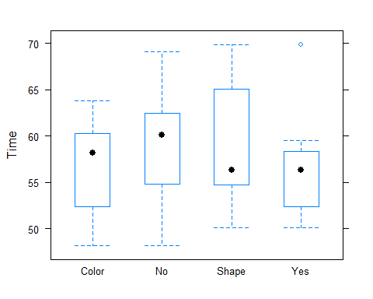

dotplot(Time~Task+timerDisplay, data = stroop, jitter.x = TRUE, main = "Shapes and Color Times")

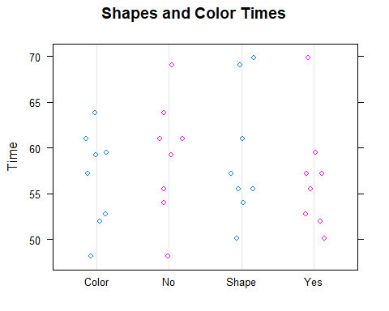

# Make an ANOVA table  
stroopMod <- aov(Time~Task+timerDisplay+Task*timerDisplay + Block, data = stroop)  
anova(stroopMod)

## Analysis of Variance Table  
##   
## Response: Time  
## Df Sum Sq Mean Sq F value Pr(>F)   
## Task 1 21.85 21.846 2.3793 0.15734   
## timerDisplay 1 19.91 19.914 2.1689 0.17492   
## Block 3 446.05 148.684 16.1934 0.00057 ***  
## Task:timerDisplay 1 0.91 0.907 0.0988 0.76043   
## Residuals 9 82.64 9.182   
## ---  
## Signif. codes: 0 '***' 0.001 '**' 0.01 '*' 0.05 '.' 0.1 ' ' 1

# Make ANOVA table without blocks  
stroopMod2 <- aov(Time~Task+timerDisplay+Task*timerDisplay, data = stroop)  
anova(stroopMod2)

## Analysis of Variance Table  
##   
## Response: Time  
## Df Sum Sq Mean Sq F value Pr(>F)  
## Task 1 21.85 21.846 0.4959 0.4948  
## timerDisplay 1 19.91 19.914 0.4520 0.5141  
## Task:timerDisplay 1 0.91 0.907 0.0206 0.8883  
## Residuals 12 528.69 44.057

# Check Assumptions  
#Independent (index plot)  
plot(stroop$Run, stroop$Time, type="b")

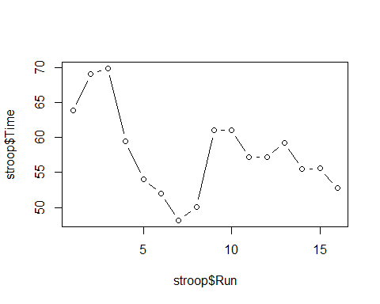

# Check mean of residuals to see if it equals 0  
stroop$resids <- resid(stroopMod)  
mean(stroop$resids)

## [1] -1.040834e-16

# Normally distributed (qqplot)  
qqnorm(stroop$resids)  
qqline(stroop$resids)

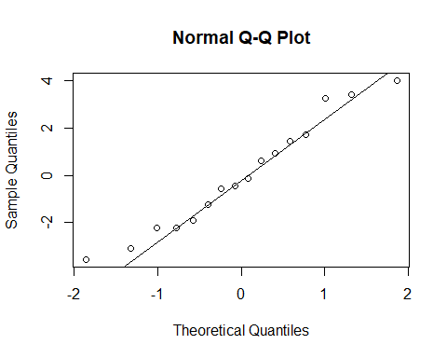

# Constant variance (sd ratio)  
aggregate(Time~Task+timerDisplay, data = stroop, FUN = sd)

## Task timerDisplay Time  
## 1 Color No 6.864280  
## 2 Shape No 6.800117  
## 3 Color Yes 3.586522  
## 4 Shape Yes 8.366955